China – Country Data
People
Population | 1 349 585 838 (July 2013 est.)
Age structure
0-14 years | 17.20%
15 - 64 years | 73.40%
65 years and over | 9.40%
Population Density people per sq km | 142
Greatest population Density (geographically) | East coast (population decreases the further you head west)
Population Growth Rate | 0.46% per year
Urban Population | 47.00%
Geography
Location | Eastern Asia, bordering the East China Sea, Korea Bay, Yellow Sea, and South China Sea, between North Korea and Vietnam
Area (in square kilometres)
land | 9,569,901 sq km
water | 27 060 sq km
Coastline Distance (in km) | 14 500 km
Climate
wind speeds | moderate to low
average rainfall (in mm) | 2-250
average sunlight hours per day | 4.5-10
geothermal activity | moderate
River flow rate (high flow = 5, low flow = 1) | 4
Terrain | mostly mountainous, high plateaus, deserts in west; plains, deltas and hills in east
Elevation extremes
lowest point | - 154 m
highest point | 8,850 m
Natural Hazards
Volcanic activity | No
Seismic Activity | Yes
Tsunamis | Yes
Tropical storms - Typhoons/Cyclones/Hurricanes | southern and eastern coast
Tornadoes | No
Severe Storms | Yes
Extensive regular flooding | Yes
Wildfires | No
Natural Hazards
Landslides / Avalanches | Yes
Droughts | Yes
Environmental concerns - Current Issues
Air pollution | Yes
Acid Rain | Yes
Soil erosion | Yes
Desertification | Yes
water shortages | Yes
Deforestation | Yes
Oil spills | Yes
water pollution from untreated wastes | Yes
Energy
Obligations to the Kyoto Protocol (2013 - 2020) | No binding targets, only to monitor emissions
Presents of a Carbon Trading Scheme (CO2 emission credit trading) | pilot scheme in Shenzen began 2013
Strength of Environmental Movement | Well established and high profile
Coal proved reserves (tons) | 126 billion
Uranium Reserves | 171000
Total renewable water resources (in cubic km) | 2840
Natural Gas Reserves (in cubic metres) | 3.03 trillion
Natural Resources | coal, petroleum, natural gas, uranium, hydropower potential
Electricity
Total Electricity Production (in TWh) | 4.94 trillion kWh (2012)
Current electricity production
Electricity Production in thermal plants | 69.5% of total installed capacity (2012 est.)
Electricity Production in hydroelectric plants | 21.8% of total installed capacity (2012 est.)
Electricity Production in nuclear plants | 1.1% of total installed capacity (2012 est.)
Electricity Production in other renewable plants | 7.6% of total installed capacity (2012 est.)
The average cost of transporting electricity = $2 million/km at 275V
Politics
Political stability Index (higher prospects of going to war = 5, lower prospects = 1) | 1

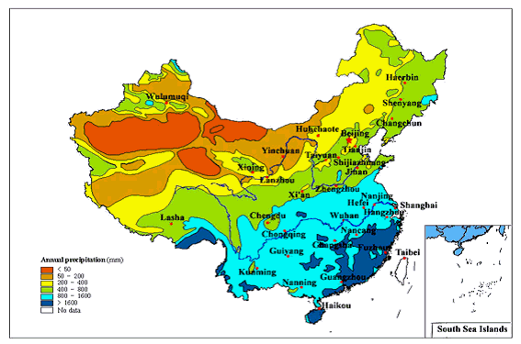
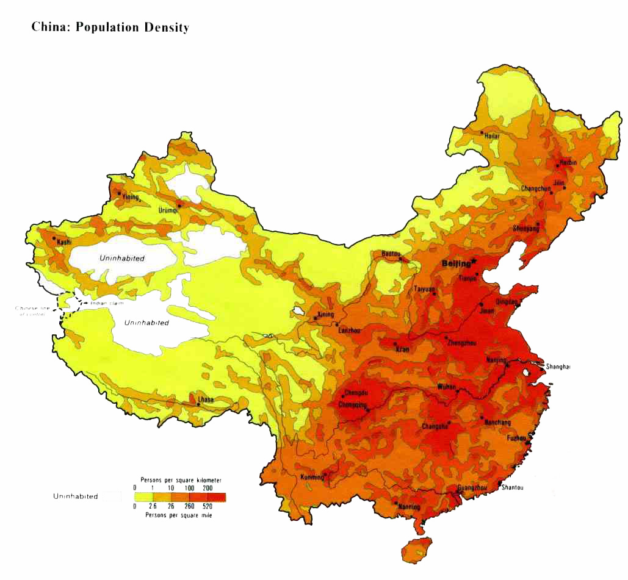
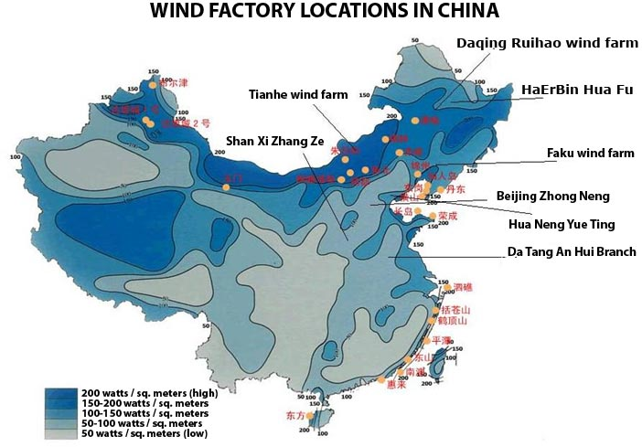
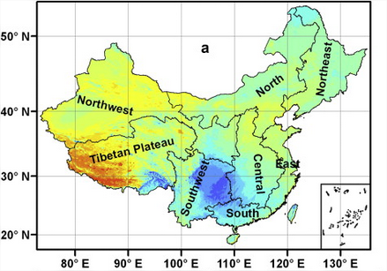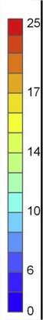
Continuous global solar radiation estimated by the ANN model [in MJ⋅m⁻²]. (a) Annual average (June 2007–May 2008).

