Brazil – Country Data
People
Population | 201,009,622 (July 2013 est.)
Age structure
0-14 years | 24.20%
15 - 64 years | 68.50%
65 years and over | 7.30%
Population Density people per sq km | 22
Greatest population Density (geographically) | Entire east coast
Population Growth Rate | 0.83% (2013 est.)
Geography
Location | Eastern South America, bordering the Atlantic Ocean
Area (in square kilometres)
land | 8459417
water | 55460
Coastline Distance (in km) | 7491
Climate
wind speeds | moderate on the coasts
average rainfall (in mm) | 0-264
average sunlight hours per day | 4.8-8
geothermal activity | none
River flow rate (high flow = 5, low flow = 1) | 5
Terrain | mostly flat to rolling lowlands in the north; some plains, hills, mountains and narrow coastal belt
Elevation extremes
lowest point | Atlantic Ocean 0 m
highest point | Pico da Neblina 2,994 m
Natural Resources | bauxite, gold, iron ore, manganese, nickel, phosphates, platinum, tin, rare earth elements, uranium, petroleum, hydropower, timber
Natural Hazards
Volcanic activity | Nil
Seismic Activity | Minor
Tsunamis | Very Low probability
Typhoons/Cyclones/Hurricanes | Very Low probability
Tornadoes | Very Low probability
Severe Storms | Yes
Natural Hazards
Flooding | Yes
Wildfires | Minor
Landslides / Avalanches | Minor
Droughts | Yes (North East)
Environmental concerns - Current Issues
Air pollution | Major cities
Acid Rain | Minor
Soil erosion | Yes
Desertification | No
water shortages | Isolated
Deforestation | Yes
Oil spills | Yes
water pollution from untreated wastes | pollution from mining
Energy
Obligations to the Kyoto Protocol (2013 - 2020) | No binding targets, only need to report emissions, a reduction in deforestation could help lower carbon dioxide emissions
Carbon dioxide emissions (tonnes per capita) | 2.3 (2010)
Strength of Environmental Movement | establishing a growing profile
Coal proved reserves (tons) | 32 billion tons
Uranium Reserves | 309,370 tonnes 6th largest in the world
Total renewable water resources (in cubic kilometres) | 8,233 cu km (2011)
Natural Gas Reserves (in cubic metres) | 416.9 billion cu m (1 January 2012 est.)
Electricity
Total Electricity Production (in kWh) | 509.2 billion (2012)
Current electricity production
Electricity Production in thermal plants | 17% (2012)
Electricity Production in hydroelectric plants | 77% (2012)
Electricity Production in nuclear plants | 1% (2012)
Electricity Production in other plants | 5% (2012)
The average cost of transporting electricity = $2 million/km at 275V
Politics
Political stability Index (higher prospects of going to war = 5, lower prospects = 1) | 2

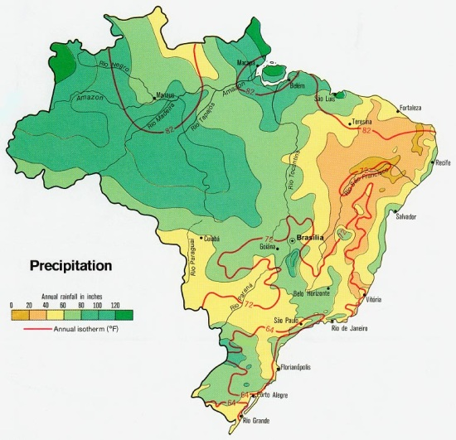
2.5mm = 1 inch
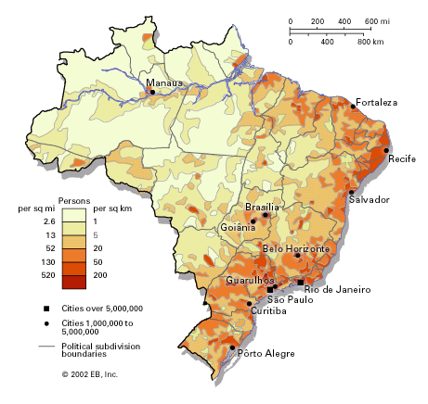
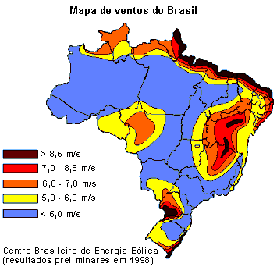Average wind speeds

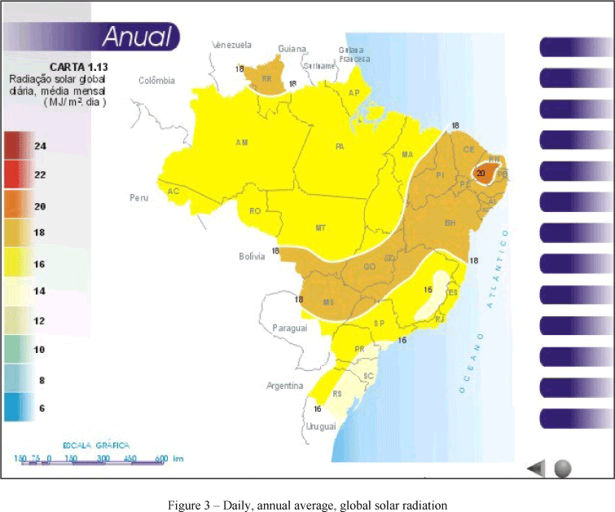
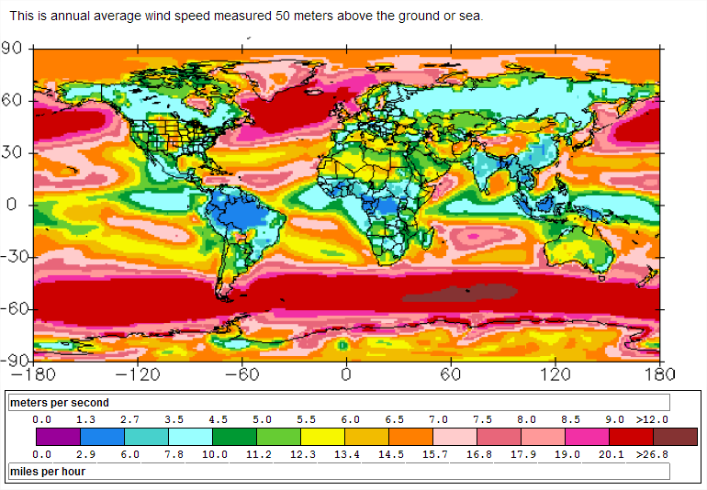
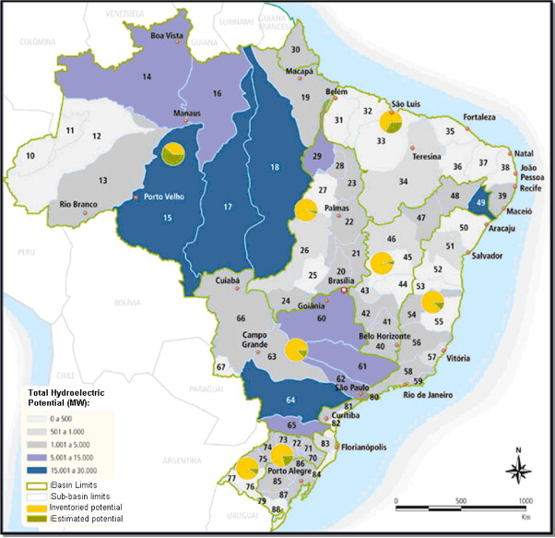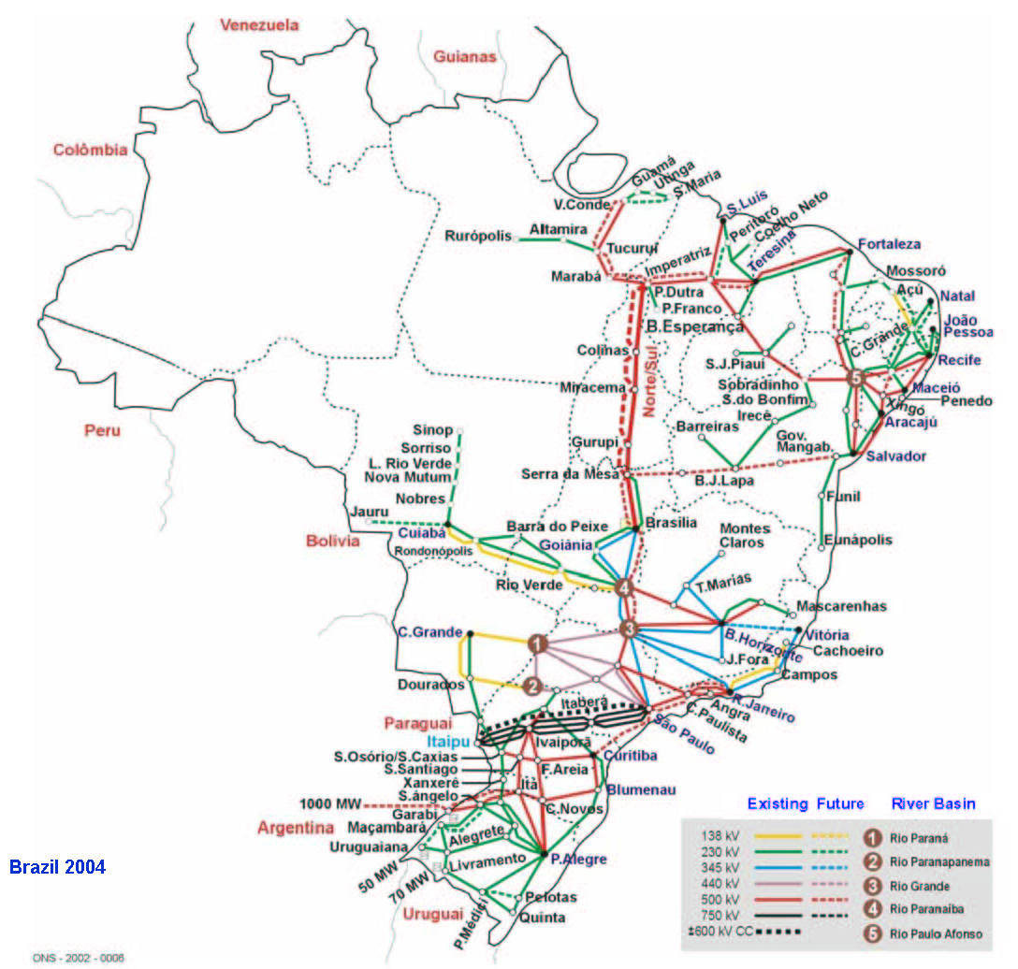
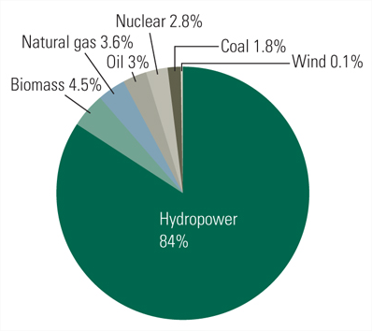
2011 Brazilian sources of electrical production

